5.30: (a) If the block descends at constant speed, the tension in the connecting string must be equal to the hanging block’s weight, 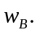 Therefore, the friction force 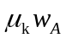 on block A must be equal to 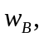 and 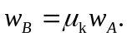
(b) With the cat on board, 